Annexure-I

Management Structure/ Organogram

Organizational Setup

Control Organs / Hierarchy (Administrative)

Control Organs / Hierarchy (Academic)

Control Organs / Hierarchy (Finance) Control Organs / Hierarchy(Examination Section)

Control Organs / Hierarchy (Library) Control Organs / Hierarchy (ORIC)

Annexure-II

Decentralization of Financial Powers
S.No. | Authority | Administrative Powers |  | Financial Powers
1 | Vice Chancellor | Section 12 (4) of BUET Act 1994 |  | Section 5.3 of Financial Rules of BUETK 2004
 |  | 1. | The Vice Chancellor shall be Principal Executive and Academic Officer of the University. | 1. | Shall be the Chief Executive of the University.
 |  | Section 13 of BUET Act 1994  (Sub section…..) |  | Section 13 of BUET Act 1994  (Sub section…..)
 |  | (i)  (ii)  (iii)  (iv)  (v)  (vi)  (ix)  (x)  (xi)  (xii)  (xiii) | to ensure that the provisions of this Ordinance, the Statute, the Regulations and the Rules are faithfully observed in order to promote teaching, research, technology development, publications, administration and the general efficiency and good order of the University. He shall have all power necessary for this purpose including administrative control over all officers, teachers and other employees of the University;  to preside in the absence of both the Chancellor and Pro-Chancellor, at convocation of the University and the meeting of the senate;  to attend and preside at the meetings of the authorities or other bodies of the University of which he may or may not be the Chairman;  to take such action, in an emergency, which he considers necessary and report his action for approval, as soon thereafter as possible, the action so taken to the officer, Authority or other body which in the ordinary course, would have dealt with the matter;  to create temporary posts for a period not exceeding one year and fill such posts;  to appoint employees below the initial monthly pay of BS-17 or equivalent and for this purpose to appoint such selection committee or committees as he may deem necessary;  to appoint paper setters and examiners for all examinations of the University, after considering panels of names received form the relevant Authorities;  to make arrangement for the scrutiny of papers compilation of marks sheets and preparation of examination results;  to assign to teachers, Officers and other employees of the University such duties of teaching, research, technology development, examination, administrations and such other activities in the University as he may consider necessary for the purpose of the University;  to delegate, subject to such conditions, as, may be prescribed, any of his powers under this Act, to any Officers or employees of the University; and  to exercise such powers and perform such functions as may be prescribed. | (vii)  (viii) | to sanction expenditure within the approved budget and if necessary re-appropriate funds within the same major head of expenditure;  to sanction, by re-appropriation, an amount not exceeding Rs.150,000/- for an unforeseen expenditure not provided for in the budget, and report it to the Syndicate at its next meeting;  Section V (Delegation of Financial Powers (Financial Rules)  Sanctioning Authority on account of: -  - Pay & Allowances  - Scholarship and other Awards to Students  - Bonus or honorarium to staff  - Pension & gratuity  - Expenditure of foreign trainees  - loan to employees  - Laboratories expenses & contingencies  - Grant of non-financial Institution (Subsidy to Schools)  - Payment of Audit Fee  - Rent for Residential Building  - Remuneration for exam duty  - Printing of Question Paper  - Travelling Allowance  - Printing of Answer Books  - Miscellaneous & Advances for examinations.  - Purchase of machinery and equipment, Transport and Furniture & Fixture.  - Purchase of sports material.  - Feasibility Studies  - Holding survey camps of students.  - Research Project  - Students Project works  - Repair & Maintenance of Durable goods, Transport, Machinery & equipment and Furniture & Fixture.  - Building (AM&R)  - Tech: sanction of estimates of works.  - POL charges.  - Students study tour  - Conveyance charges  - Postage Y Telegrams, Telephone & Telex  - Gas, Electricity, Water and other utility charges  - Office stationery.  - Printing  - Newspapers and books etc  - Law Charges  - Fairs Exhibition etc  - Publicity Y Advertisement  - Chemical and Glass ware  - Subsidies  - Unforeseen  - Insurance of labs/vehicles  - Amenities  - Entertainment & gifts  - Advance for specific item  - Approval of Recoupment of Advances  - Labours charges/ daily wages/work charges.  - G.P fund advance  - Final payment of G.P fund  - Medical Reimbursement charges
 |  | Section 19 of BUET Act
 |  | Shall be Chairman of Statutory Bodies such as Syndicate, Academic Council, Finance Committee, Planning and Development Committee, Selection Board etc and member of Senate.
 |  | Section 6 (2) (c) of BUET Revised Leave Rules 2004
 |  | Sanctioning Authority for grant of Earned leave to officers/teachers BPS-17 and above.
 |  | Section 6 (3) of BUET Revised Leave Rules 2004
 |  | Sanctioning Authority for grant of Leave not due, Study leave, Maternity Leave
 |  | Schedule of BUET (E&D) Statutes 2003
 |  | Punishing Authority in case of employees from Grade 17 and above and appellate Authority in case of employees grade 16 and below.
2 | Registrar | Section 14 (1) of BUET Act 1994, clauses…. |  |  | Section –B Delegation of Financial Powers of Financial Rules
 |  | - be the custodian of the common seal and the academic records of the University;  - maintain a register of registered graduates in the prescribed manner;  - conduct elections of members to the Authorities in the prescribed manner; and  - Perform such other duties as may be prescribed. |  |  | All such powers defined in the list being delegated by the Vice Chancellor
- Shall be Secretary of BUET Senate, Syndicate, Academic Council, Selection Board etc
- Sanctioning Authority of Earned leave to staff upto BPS-16.
- Sanctioning Authority of Casual leave to his immediate sub ordinates.
- Punishing authority in case of employees upto BPS-16.
3 | Controller of Examinations | To be appointed as per Section 16 (1) of BUET Act 1994 |  |  | Section –B Delegation of Financial Powers of Financial Rules
 |  | - Incharge of Examination Section  - Ex-Officio member of Academic Council  - Sanctioning Authority for Casual leave to his sub ordinate staff. |  |  | All such powers defined in the list being delegated by the Vice Chancellor
4 | Treasurer | Section 15 (1) of BUET Act 1994, clauses…. |  |  | Section –B Delegation of Financial Powers of Financial Rules
 |  | - manage the property, the finances and investments of the University;  - prepare an annual and revised budget estimates of the University and present them before the Finance Committee;  - ensure that the funds of the University are expended for the purposes they are provided; and  - perform such other duties as may be prescribed. |  |  | All such powers defined in the list being delegated by the Vice Chancellor
- Secretary of the Finance Committee.
- Sanctioning Authority in case of Casual leave to his sub ordinate staff.
5 | Dean | Section 8 (iv) of BUET Act 1994 |  |  | Section –B Delegation of Financial Powers of Financial Rules
 |  | - Academic Head of the respective faculty  - Ex-officio member of BUET Syndicate, Academic Council, Board of Advance Studies Research & Technological Development etc.  - Chairman Admission Cell.  - Chairman Higher Studies Committee. |  |  | All such powers defined in the list being delegated by the Vice Chancellor
6 | Concerned Head of Department | Section 8 (v) of BUET Act 1994 |  |  | Section –B Delegation of Financial Powers of Financial Rules
 |  | - Head of respective Academic Department.  - Member of Board of Studies.  - Member of Selection Board.  - Member of Admission Cell.  - Sanctioning Authority for grant of casual leave to faculty members and other staff of his respective department. |  |  | All such powers defined in the list being delegated by the Vice Chancellor

Annexure-III

Plan to Build Dedicated Campus on Owned Land
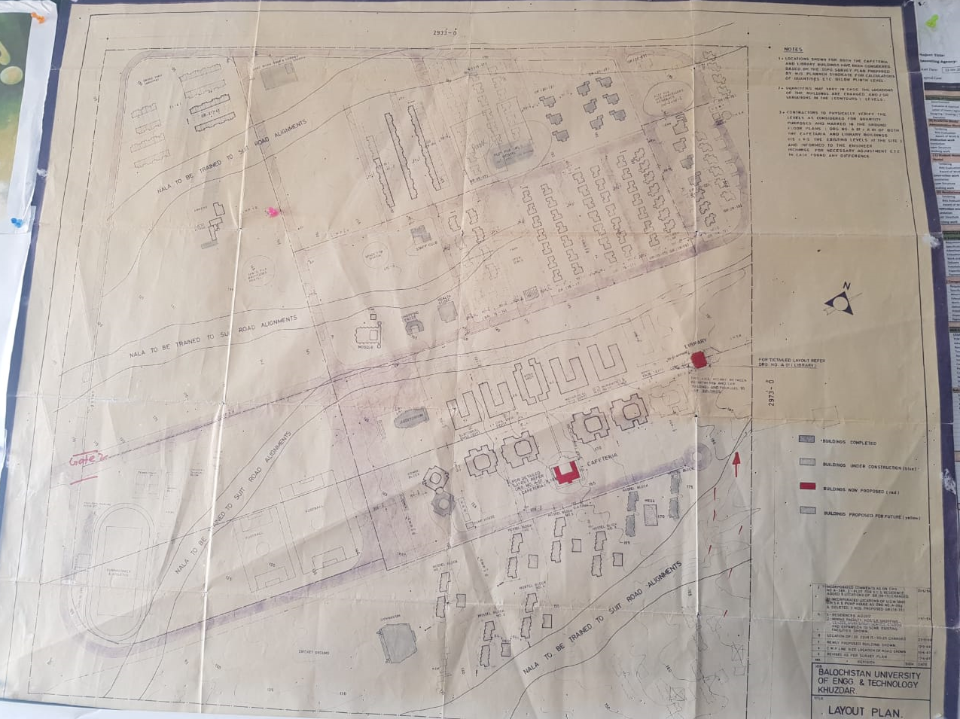

Annexure-III

Faculty Offices
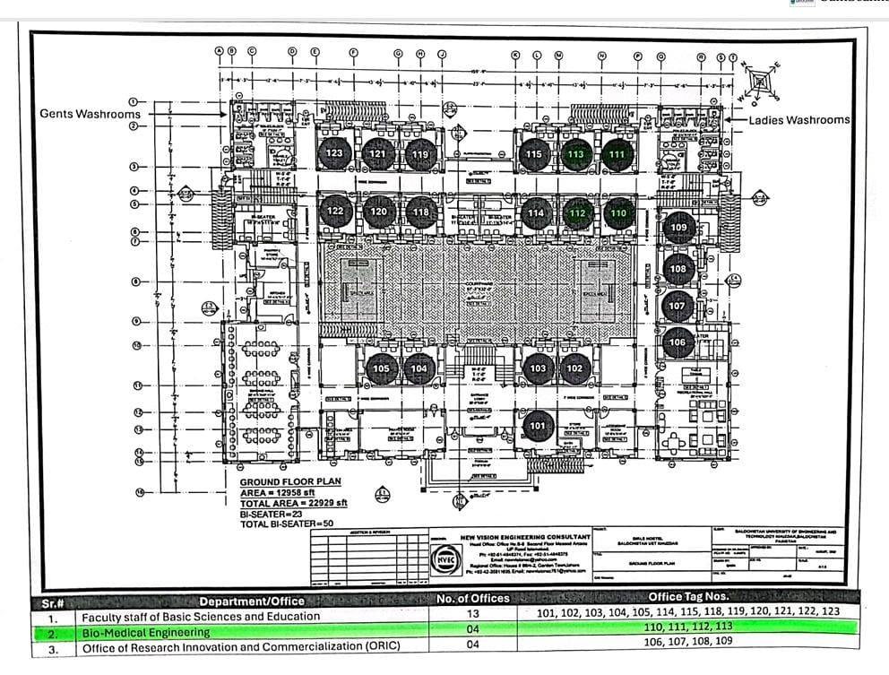

Annexure-IV

Breakup of the Current Budget for the Program (2023 - 2024)

S.No. | Budget Head | Annual Allocation (Rs)
1 | Operational Budget
 | 1.1 HEC Grant | 304.390 Million
 | 1.2 Grant in Aid (UFC) | 218.514 Million
 | 1.3 Own Resources | 185.830 Million
 | Total | 708.734 Million
 | Expenditure
 | Establishment Charges | 490.078 Million
 | Non Salary Expenses | 255.713 Million
 | Total | 745.791 Million
 | .
a. Sub-total |  | 708.734 million
2 | Development Budget
 | 2.1
 | 2.2
 | 2.3
 | .
 | .
 | .
b. Sub-total
Total (a+b)

Annexure-V
Break-up of Projected Budget for Next Year (2024 - 2025)

S.No. | Budget Head | Annual Allocation (Rs)
1 | Operational Budget
 | 1.1 HEC Grant | 304.390 Million
 | 1.2 Grant in Aid (UFC) | 450.780 Million
 | 1.3 Own Resources | 160.950 Million
 | Total | 916.120 Million
 | Expenditure
 | Establishment Charges | 578.244 Million
 | Non Salary Expenses | 380.005 Million
 | Total | 958.249 Million
 | .
a. Sub-total |  | 916.120 million
2 | Development Budget
 | 2.1 | 1 Million
 | 2.2 | PC-1 submitted to Govt. of Balochistan
 | 2.3 | BIOMED 5.0 Fund =57000 Euros=17.12742840 Million
 | .
 | .
 | .
b. Sub-total |  | 18.12742840 Million
Total (a+b) |  | 976.3764284 Million

Annexure-VI
(For Semester System)
Composition of Curriculum for all semesters / years including details of Credit-hours

National/International Model being followed if any (In case of New Program):

Course No. | Course Title | Knowledge Area | Sub Area | Credit Hours (Theory+Practical) | Contact Hours (Theory+Practical) | Total Credit Hours | Marks Theory | Marks Practical
Semester-I
1. | Applied Physics | Natural Science | Physics | 2+1 | 32+48 | 3 | 80 | 20
2. | Introduction to Computing | Computing | Fundamentals | 2+1 | 32+48 | 3 | 80 | 20
3. | Basic Electrical Engineering | Biomedical Engineering Foundation | Core | 3+1 | 48+48 | 4 | 80 | 20
4. | Basic Mathematics | Natural Science | Core | 4+0 | 64+0 | 4 | 100 | 0
 | Basic Biology | Natural Science | Core | 4+0 | 64+0 | 4 | 100 | 0
5. | Introduction to Biomedical Engineering | Biomedical Engineering Foundation | Core | 1+0 | 16+0 | 1 | 100 | 0
6. | Islamic Studies | Humanities | Culture | 2+0 | 32+0 | 2 | 100 | 0
 | Ethical Behavior | Humanities | Culture | 2+0 | 32+0 | 2 | 100 | 0
Semester-II
1. | Pakistan Studies | Humanities | Culture | 2+0 | 32+0 | 2 | 100 | 0
2. | Calculus & Analytical Geometry | Natural Science | Mathematics | 3+0 | 48+0 | 3 | 100 | 0
3. | Physiology I | Biomedical Engineering Foundation | Core | 2+1 | 32+48 | 3 | 80 | 20
4. | Circuit Analysis | Biomedical Engineering Foundation | Core | 3+1 | 48+48 | 4 | 80 | 20
5. | Object Oriented Programming | Computing | Fundamentals | 2+1 | 32+48 | 3 | 80 | 20
6. | Human Anatomy | Biomedical Engineering Foundation | Core | 2+1 | 32+48 | 3 | 80 | 20
Semester-III
1. | Complex Variable & Transformation | Natural Science | Core | 3+0 | 48+0 | 3 | 100 | 0
2. | Physiology II | Biomedical Engineering Foundation | Core | 2+1 | 32+48 | 3 | 80 | 20
3. | Biochemistry | Natural Science | Core | 2+1 | 32+48 | 3 | 80 | 20
4. | Basic Electronics | Biomedical Engineering Foundation | Core | 3+1 | 48+48 | 4 | 80 | 20
5. | Computer Aided Engineering Drawing | Biomedical Engineering Foundation | Core | 0+1 | 0+48 | 1 | 0 | 100
6. | Communication Skills | Humanities | English | 2+0 | 32+0 | 2 | 100 | 0
Semester-IV
1. | Biomedical Electronics | Major Based  Breadth | Core | 3+1 | 48+48 | 4 | 80 | 20
2. | Digital Logic Design | Biomedical Engineering Foundation | Core | 3+1 | 48+48 | 4 | 80 | 20
3. | Linear Algebra & Differential Equation | Natural Science | Mathematics | 3+0 | 48+0 | 3 | 100 | 0
4. | Probability & Statistics | Major Based  Depth | Core | 3+0 | 32+48 | 3 | 80 | 20
5. | Signals & Systems | Major Based  Breadth | Core | 3+1 | 48+48 | 4 | 80 | 20
Semester-V
1. | Biomedical Instrumentation 1 | Major Based  Breadth | Core | 3+1 | 48+48 | 4 | 80 | 20
2. | Biomechanics | Major Based  Breadth | Core | 2+1 | 48+0 | 3 | 100 | 0
3. | Numerical Methods | Natural Science | Mathematics | 3+0 | 48+0 | 3 | 100 | 0
4. | Microprocessor & Interfacing | Major Based  Breadth | Core | 2+1 | 32+48 | 3 | 80 | 20
5. | Biomedical Signal Processing | Major Based  Breadth | Core | 3+1 | 48+48 | 4 | 80 | 20
Semester-VI
1. | Biomedical Instrumentation II | Major Based  Depth | Core | 3+1 | 48+48 | 4 | 80 | 20
2. | Elective I |  |  | 3+0 | 48+0 | 3 | 100 | 0
3. | Biomedical Control Systems | Major Based  Depth | Core | 3+1 | 48+48 | 4 | 80 | 20
4. | Modeling & Simulation | Computing | Design | 2+1 | 32+48 | 3 | 80 | 20
5. | Biomaterials | Interdisciplinary Engineering Breadth |  | 3+1 | 48+48 | 4 | 80 | 20
Semester-VII
1. | Engineering Management | Management  Sciences |  | 3+0 | 48+0 | 3 | 100 | 0
2. | Medical Imaging | Interdisciplinary Engineering Breadth |  | 2+1 | 32+48 | 3 | 80 | 20
3. | Elective II | Interdisciplinary Engineering Breadth |  | 3+0 | 48+0 | 3 | 100 | 0
4. | Elective III | Interdisciplinary Engineering Breadth |  | 3+0 | 48+0 | 3 | 100 | 0
5. | Technical Report Writing | Humanities | English | 3+0 | 48+0 | 3 | 100 | 0
6. | Biomedical Engineering Project (Phase I) | Senior Design Project |  | 0+3 | 0+48 | 3 | 0 | 100
Semester-VIII
1. | Elective IV | Interdisciplinary Engineering Breadth |  | 3+0 | 48+0 | 3 | 100 | 0
2. | Professional Practices & Ethics | Humanities | Social Science | 3+0 | 48+0 | 3 | 100 | 0
3. | Elective V | Interdisciplinary Engineering Breadth |  | 3+0 | 48+0 | 3 | 100 | 0
4. | Biomedical Engineering Project (Phase II) | Senior Design Project |  | 0+3 | 0+48 | 3 | 0 | 100
5. | Entrepreneurship | Management  Sciences |  | 3+0 | 48+0 | 3 | 100 | 0

Annexure-VII

Requirement of faculty and its availability plan for entire program

S.# | Subjects to be Taught | Faculty Designation | Qualification | Credit Hours
 |  |  |  | Semester-I |  | Semester-II |  | Semester-III |  | Semester-IV |  | Semester-V |  | Semester-VI |  | Semester-VII |  | Semester-VIII
 |  |  |  | Theory | Pract | Theory | Pract | Theory | Pract | Theory | Pract | Theory | Pract | Theory | Pract | Theory | Pract | Theory | Pract
1. Core Engineering Subjects
i | Applied Physics | Mr. Saifullah  Lecturer | MS | 2 | 1
ii | Introduction to Computing | Engr. Hassina Qadir  Lecturer | MS | 2 | 1
iii | Basic Electrical Engineering | Engr. Hammal Khan  Lecturer | MS | 3 | 1
iv | Introduction to Biomedical Engineering | Engr. Nazia Ejaz  Lecturer | PhD | 1 | 0
v | Basic Biology I | Ms Nehl Memon  Lecturer | MS | 4 | 0
 | Basic Biology II | Ms Nehl Memon  Lecturer | MS | 4 | 0
vi | Physiology I | Dr. Nazia Ejaz  Assistant Professor | PhD |  |  | 2 | 1
Vii | Circuit Analysis | Dr. Wazir Muhammad  Assistant Professor | PhD |  |  | 3 | 1
Viii | Object Oriented Programming | Engr. Sher Muhammad  Lecturer | MS |  |  | 2 | 1
ix | Human Anatomy | Dr. Nazia Ejaz  Assistant Professor | PhD |  |  | 2 | 1
x | Physiology II | Ms Nehl Memon  Lecturer | MS |  |  |  |  | 2 | 1
xi | Biochemistry | Dr. Nazia Ejaz  Assistant Professor | PhD |  |  |  |  | 2 | 1
xii | Basic Electronics | Engr. Muhammad Ibrahim  Lecturer | MS |  |  |  |  | 3 | 1
xiii | Computer Aided Engineering Drawing | Engr. Nazaruddin Khoso  Lab Engineer | BS |  |  |  |  | 0 | 1
xiv | Biomedical Electronics | Dr. Muhammad Ilyas  Assistant Professor | PhD |  |  |  |  |  |  | 3 | 1
xv | Digital Logic Design | Dr. Muhammad Ilyas  Assistant Professor | PhD |  |  |  |  |  |  | 3 | 1
xvi | Biomechanics | Dr. Nazia Ejaz  Assistant Professor | PhD |  |  |  |  |  |  | 2 | 1
xvi | Signals & Systems | Dr. Wazir Muhammad  Assistant Professor | PhD |  |  |  |  |  |  | 3 | 1
xvii | Biomedical Instrumentation 1 | Ms Nehl Memon  Lecturer | MS |  |  |  |  |  |  |  |  | 3 | 1
xviii | Microprocessor & Interfacing | Engr. Muhammad Raziq  Lab Engineer | MS |  |  |  |  |  |  |  |  | 2 | 1
xix | Biomedical Signal Processing | Dr. Wazir Muhammad  Assistant Professor | PhD |  |  |  |  |  |  |  |  | 3 | 1
xx | Biomedical Instrumentation II | Dr. Nazia Ejaz  Assistant Professor | PhD |  |  |  |  |  |  |  |  |  |  | 3 | 1
xxi | Biomedical Control Systems | Dr. Wazir Muhammad  Assistant Professor | PhD |  |  |  |  |  |  |  |  |  |  | 3 | 1
xxii | Modeling & Simulation | Dr. Muhammad Ilyas  Assistant Professor | PhD |  |  |  |  |  |  |  |  |  |  | 2 | 1
xxiii | Biomaterial & Designs | Ms Nehl Memon  Lecturer | MS |  |  |  |  |  |  |  |  |  |  | 3 | 1
xxiv | Engineering Management | Ms. Sadia Baber  Assistant Professor | PhD |  |  |  |  |  |  |  |  |  |  |  |  | 3 | 0
xxv | Medical Imaging | Dr. Wazir Muhammad Lecturer | PhD |  |  |  |  |  |  |  |  |  |  |  |  | 2 | 1
2. Shared Engineering Subjects
i | Basic Mathematics | Mr. Majid  Lecturer | MS | 4 | 0
ii | Calculus & Analytical Geometry | Mr. Majid  Lecturer | MS |  |  | 3 | 0
iii | Complex Variable & Transformation | Mr. Mumtaz Ali  Lecturer | MS |  |  |  |  | 3 | 0
iv | Linear Algebra & Differential Equation | Mr. Dur Muhammad  Lecturer | MS |  |  |  |  |  |  | 3 | 0
v | Probability & Statistics | Mr. Majid  Lecturer | MS |  |  |  |  |  |  |  |  | 3 | 0
vi | Entrepreneurship | Ms. Sadia Baber  Assistant Professor | PhD |  |  |  |  |  |  |  |  |  |  |  |  |  |  | 3 | 0
3. Basic Science & Humanities
i | Pakistan Studies | Mr. Habib us Salam  Lecturer | MS |  |  | 2 | 0
ii | Islamic Studies | Mr. Gul Muhammad  Lecturer | MA | 2 | 0
iii | Professional Practices & Ethics | Ms. Sadia Baber  Assistant Professor | PhD |  |  |  |  |  |  |  |  |  |  |  |  |  |  | 3 | 0
iv | Technical Report Writing | Ms. Hajira Masroor  Assistant Professor | PhD In Progress |  |  |  |  |  |  |  |  |  |  |  |  | 3 | 0
v | Communication Skills | Ms. Maryam Shah  Lecturer | MS |  |  |  |  | 2 | 0

Annexure-VIII

Present strength with relevance to the proposed program, qualification and experience

Sr# | Name of Faculty Member | PEC Regn # | Designation | Joining  Date | Nature (Full time/ Part time) | Details of Qualifications |  |  | Specialization for each level of education | Experience |  | Utilization (Dedicated/ Shared)
 |  |  |  |  |  | Qualification  BSc Engg  MSc Engg  PhD Engg | Year | Institution |  | Total | Teac-hing
1 | Dr. Wazir Muhammad | ELECT/15508 | Assistant Professor | 28 Oct 1999 | Full time | Ph. D | 2019 | Chulalongkorn University Bangkok  Thailand | (Ph. D)  Electrical Engineering (ME)  Communication systems & networks  (BE)  Electrical Engineering | 22 | 22 | Dedicated
2 | Dr. Muhammad Ilyas | Electro/20376 | Assistant Professor | 3 Feb 2022 | Full time | Ph. D | 2019 | COMSATS University Islamabad | (Ph. D)  Electrical Engineering (ME)  Electrical Engineering  (BSc)  Electronic Engineering | 7 | 5 | Dedicated  (On Leave)
3 | Engr. Nazia Ejaz | BIOMEDICAL/  01093 | Assistant Professor | 12 Nov 2021 | Full time | PhD | 2023 | Ziauddin University, Faculty of Engineering Science & Technology  Karachi | (Ph. D)  Electrical Engineering (Research Area: Biomechanics &Rehabilitation Engineering)  (MS)  Biomedical Engineering  (BS)  Biomedical Engineering | 11 | 11 | Dedicated
7 | Engr. Nehl Memon | BIOMEDICAL/002614 | Lecturer | Feb 2025 | Full time | MS | 2024 | Ziauddin University, Faculty of Engineering Science & Technology  Karachi | (MS)  Biomedical Engineering  (BS)  Biomedical  Engineering | 4 | 1.5 | Dedicated
8 | Engr.Nazaruddin Khoso | BIOMEDICAL/02111 | Lab Engineer | Feb 2025 | Full time | BS | 2018 | Liaquat University of Medical Sciences, Jamshoro | (BS)  Biomedical Engineering | 1.5 | 1.5 | Dedicated
9 | Engr. Muhammad Ibrahim | ELECT/47278 | Lecturer | 20 May 2016 | Full time | ME | 2021 | Balochistan University of Engineering & Technology, Khuzdar | (MS)  Electrical Power  (BE)  Electrical Engineering | 9 | 9 | Dedicated
10 | Engr. Hammal Khan | ELECT/37376 | Lecturer | 21 May 2016 | Full Time | ME | 2018 | Balochistan University of Engineering & Technology, Khuzdar | (MS)  Electrical Power  (BE)  Electrical Engineering | 11 | 11 | Dedicated

Annexure-IX

Expected strength one month prior to commencement of the program along with documentary proof

S. No. | Name of Faculty | Qualification (with PEC Reg #, if applicable) | Field of Specialization | Designation | Expected Date of Joining | Subject(s) to be Taught | Planned Work Load | Other Information, if any
i | Dr. Wazir Muhammad | ELECT/15508 | Deep Learning, Artificial Intelligence | Assistant Professor | 28 Oct 1999 | Circuit Analysis | 12 Credit Hours | NA
 |  |  |  |  |  | Biomedical Signal Processing
 |  |  |  |  |  | Signal & System
 |  |  |  |  |  | Biomedical Control System
 |  |  |  |  |  | Medical Imaging
ii | Dr. Muhammad Ilyas | Electro/20376 | Automation & control system | Assistant Professor | 3 Feb 2022 | Basic Electrical Engineering | 12 Credit  Hour | NA
 |  |  |  |  |  | Applied Physics
 |  |  |  |  |  | Modeling & Simulation
 |  |  |  |  |  | Biomedical Electronics
 |  |  |  |  |  | Digital Logic Design
iii  iv | Dr. Talal Jamil Qazi  Dr. Munezza Khan | NA  NA | Neurogenetics  Biomedical Science & Nano Engineering | HEC IPFP Fellow  Assistant Professor | 20 Oct 2021  13 Nov 2020 | Basic Biology I | 9 Credit Hours  9 Credit Hours | NA  NA
 |  |  |  |  |  | Biochemistry
 |  |  |  |  |  | Human Anatomy
 |  |  |  |  |  | Physiology I
 |  |  |  |  |  | Human Anatomy
 |  |  |  |  |  | Basic Biology II
v | Engr. Nazia Ejaz | BIOMEDICAL/  01093 | Biomedical Engineering | Lecturer | 12 Nov 2020 | Introduction to Biomedical Engineering | 12 Credit Hours | NA
 |  |  |  |  |  | Biomechanics
 |  |  |  |  |  | Biomedical Instrumentation I
 |  |  |  |  |  | Biomedical Instrumentation II
 |  |  |  |  |  | Rehabilitation Engineering
 |  |  |  |  |  | Telemedicine System
vi | Engr. Muhammad Waqar | ELECTRO/16918 | Biomedical Engineering | Lecturer | 27 Nov 2020 | Introduction to computing | 12 Credit Hours | NA
 |  |  |  |  |  | AutoCAD
 |  |  |  |  |  | Power Electronics
 |  |  |  |  |  | Object Oriented Programming
 |  |  |  |  |  | Signals & Systems
 |  |  |  |  |  | Entrepreneurship
vii | Mr. Shah e Mazar | NA | Mathematics | Lecturer | 13 March 2012 | Calculus & Analytical Geometry | 4 Credit Hours | NA
viii | Mr. Mehboob Shah | NA | Mathematics | Lecturer | 1 Nov 2012 | Probability & Statistics | 6 Credit Hours | NA
 |  |  |  |  |  | Complex Variable & Transformation
ix | Mr. Mumtaz Ali | NA | Mathematics | Lecturer | 18 Sep 2017 | Linear Algebra & Differential Equation | 3 Credit Hours | NA
x | Mr. Gul Muhammad | NA | Islamic Studies | Lecturer | 20 July 1995 | Islamic Studies | 2 Credit Hours | NA
xi | Mr. Habib Us Salam | NA | Pakistan Studies | Lecturer | 17 March 2014 | Pakistan Studies | 2 Credit Hours | NA
xii | Ms. Hajira Masroor | NA | English | Assistant Professor | 29 Jan 2015 | Technical Report Writing | 4 Credit Hours | NA
 |  |  |  |  |  | Communication Skills

Annexure-X
Number of labs dedicated/ shared/projected for the program along with Lab staff

Sr# | Name of Lab. | No. of Workstations | Name of equipment/workstation | Status of Workstation  (Existing/ shared/ Projected) | Strength of Students per Workstation | Status of Lab  (Existing/shared/ Projected) | Lab Staff
 |  |  |  |  |  |  | Designation of Existing/ Projected Lab Staff | Qualification | Name  (For existing staff) | Joining Date/ Projected staff availability
1 | Basic Electronic Lab | 7 | Regulated Power Supply, Digital Oscilloscope, Diode, Resistor, DMM, Bread Board, Transformer, Capacitors, Transistors, Ammeter & Connecting wires. KL-210 trainer | Shared with Electrical Department | 4 students/work station | Shared | Lab Engineer | ME | Engr. Muhammad Tayyab | 25-05-2016
 |  |  |  |  |  |  | Lab Assistant | F.Sc. +TTC | Muhammad Ibrahim | 17-08-2000
2 | Basic Electrical Engineering Lab | 8 | Decade Resistor Box, Fixed Resistor Box, Digital Multimeter, Digital Analog Wattmeter, Fuse, Inductors, Function Generator, Digital Storage Oscilloscope | Shared with Electrical Department | 4 students/work station | Shared | Lecturer | ME | Engr. Muhammad Ibrahim | 20-05-2016
 |  |  |  |  |  |  | Lab Assistant | Matric | Sikandar Ali | 19-04-1988
3 | Digital Logic Design | 18 benches | M-10 Digital System and Converter, M-15 Development Module, Voltmeter, Signal Generator, Regulated DC Power Supply, Ampere Meter, Soldering Iron, Breadboard | Shared with Computer System Engineering Department | 4 students/station | Shared | Lab Lecturer | BE | Engr. Muhammad Idrees | 03-09-2018
 |  |  |  |  |  |  | Lab Assistant | D.A.E | Mr. Sana Ullah | 09-12-2016
4 | Computer Lab | 23 | Computers Core 2 Due, Core i3, Core i7, Turbo C, Visual C++ software’s | Shared with Electrical Department | 2 students/workstation | Shared | Lab Instructor | DAE/DIT | Sayed Khan | 31-12-1994
 |  |  |  |  |  |  | Lab Assistant |  | Haseeb Hussain | 16-08-2003
 |  |  |  |  |  |  | Lab Attendant | Matric | Muhammad Irfan | 06-07-2018
5 | Physiology Lab | 7 | Electro thermal constant temperature box, Stethoscope, Sphygmomanometer, K-measurement scale, Hamo meter, Super Cotton Wool, Blood Centrifuge, etc.  All necessary reagents and consumables purchased by BUETK | Shared with Jhalawan Medical College | 4 students/workstation | Shared | Lab Demonstrator | MBBS  FCPS(In Progress) | Dr. Ayub Zarkoon | -
6 | Anatomy Lab | 7 | Male Torso Model, Cross-sectional Torso Model, Upper Limbs, Lower Limbs, Head & Neck, Special Sense, Brain, Pelvis, Abdomen Viscera, Liver, Kidney, CVS, Repertory System, Human Bone | Shared with Jhalawan Medical College | 4 students/workstation | Shared | Lab Demonstrator | MBBS | Dr. Ravi Singh | -
7 | Biochemistry Lab |  | Centrifuge Model 800, Electronic Compact Scale, Reagent Battle (L, M, S), 5-Sutfosalicyclic (S), Starch Soluble, Phenylhydrazone, Lead Acetate trihydrate, Sodium Acetate Trihydrate, PH meter, Test tube holder, Burettes, Pipette, Water Bath, Gas Cylinder, etc.  All necessary reagents and consumables purchased by BUETK | Shared with Jhalawan Medical College | 4 students/workstation | Shared | Lab Demonstrator | MBBS | Dr. Imtiaz Pandarani | -
8 | Biomechanics Lab | 3 | Retractable Posture grid, 34 Inch Adult Human Anatomical skeleton, Human Muscle Model, Audiometer, Analog Height and Weight Machine, Electro goniometer with Probes, LED Monitor, Desktop System Intel core i7-3770, Passport 2-Axis Force Platform PS2142, Handle set Force Platform, Human structure set, Vertebral Disc, Stop watch, Scoliometer, Dumbbells, Four Foot Walking Aid, Wheeled walker, Ultrasound therapy unit, TENS machine, Diathermy machine, Triball Incentive Spirometer, Molecular model of Chitosan, Model of repeating units of DNA/RNA | Projected/Already Tendered the lab Equipment’s | 4 students/workstation | Projected | Lab Engineer | BE | Advertised positions for hiring | -
9. | Applied Physics Lab | 8 | Internia test apparatus, Spark timer, Dynamics Slide , Pulley demonstration set, Young’s modulus apparatus, simple harmonic oscillation apparatus, Stop Watch, Heat conduction apparatus, Thermal Conductivity apparatus, Venturi meter, Reynold apparatus, viscose flow air meter, Bernoulli’s principle apparatus, Universal Testing Machine, microscope. | Shared with Mechanical Engineering Department | 4-5 | Shared | Lab Engineer | BE | Engr. Shahzaib Sheikh | 1st June 2016
N. B. For projected Lab/Equipment/Lab staff, please give projected timeframe.

Observations and Recommendations
(To be filled by the PEC Visitation Team)

a. Observations:

Please consolidate overall assessment/ evaluation on following key parameters and give targets to be achieved within month(s)/year: |  | Remarks
1. Legal Status
2. Adequacy of Infrastructure and Finances
3. Curriculum
4. Faculty *
5. Students *
6. Laboratories *
7. Library
8. Examination
9. Major observations of last visit*
10. Any Other Observation
b. Recommendations:

For Zero Visit  (Tick as applicable): | i. Green signal to launch the program in __________
 | ii. The intake must be restricted to ___________
 | iii. Observations of the visiting team must be addressed.
 | iv. Not ready to be launched (rejected) at this moment. Convincing reasons must be given.
For Interim Visit  (Tick as applicable): | i. The observations during Zero Visit have been addressed satisfactorily. The program may proceed ahead.
 | ii. The suggested improvements have not been incorporated. The institute must stop the program.
* Attached as Annexure respectively at the end of the report.

Signature:

Name of Expert,
Institution/ Organization, and area of expertise

Signature:

Signature:
Name of Convener / Expert,
Institution/ Organization, and area of expertise
Name of PEC Rep, and office address

Dated:_____________

